VISVESHWARAYA TECHNOLOGICAL UNIVERSITY

Jnana Sangama , Belgaum-590014



DEPARTMENT OF COMPUTER SCIENCE AND ENGINEERING

Academic Year 2019-2020

lll B.E -5th  semester

Database system

Project report

On

**!-CLONE**

**[Photo sharing social Networking Service]**

Presenting by:

|  |  |
| --- | --- |
| Student Name | USN |
| Vishwas M Gowda | 1SK17CS039 |
| Lekhana D | 1SK17CS014 |

Under the Guidance of :

Mr.Naveen Kumar T.H. Dept of CSE,GSKSJTI



GOVT SRI KRISHNARAJENDRA SILVER JUBLIEE TECHNOLOGICAL INSTITUTE

(Affiliated to Visveswaraya Technological University, Belgaum)

K.R CIRCLE. BANGALORE-01

PROJECT PROFILE:

**PROJECT TITLE:**​ **!-CLONE** [ Photo Sharing Social Networking Service].

**Objectives :** ​The main objectives of this system is to make connections with people who see the world in interesting ways. Sharing photos, viewing friends profile, adding locations, commenting on Photos. It is a simple mechanism of liking and commenting provide great fun and feedback.

**Submitted to** : Department of Computer Science.

**Developed by :** Lekhana D (1SK17CS014)

Vishwas M Gowda (1SK17CS039)

**ABSTRACT : !-Clone,** the photo sharing social network service which will helps share Photos with friends. Some people are very much excited in sharing their opinion , Photos, presenting their skills, work ,this will be open platform for those people. We can write whatever we want and post our random clicks rather than waiting for anyone to do that.

Also most of the people are busy in their schedule, This website will help them to get connected with their friends. They can view their friends Photos , like and Comment on their photos. People can Upload their Photos with Location and Caption describing their status. People have their First Name, Last Name, User Name ,Date of Birth , e-mail ,Profile-picture and also Uploaded photos in their particular Account. This will be one of the most interesting projects that one can work on and implement.

**Upload Module:** This module helps to upload the Photos with Caption and Location.

**Account Module:** This module helps to view the Account information of the particular user.

**Search Module:** This module helps to search the Account of Friend by username.

**Requirements:**

SYSTEM : MacBook Pro.

HARD DISK : 1TB.

RAM: 8GB.

MONITOR: AMD Radeon HD 6750M.

MOUSE: TRACK PAD.

GRAPHICS : AMD Radeon HD 6750M 512 MB

Intel HD Graphics 3000 512 MB.

OPERATING SYSTEM: macOS.

PROCESSOR: Intel Core i7.

FRONT-END: E-JS,HTML,CSS,BOOTSTRAP 4, JAVA SCRIPT.

BACK-END: NODE-JS,MY-SQL.

**SCHEMA DIAGRAM:**

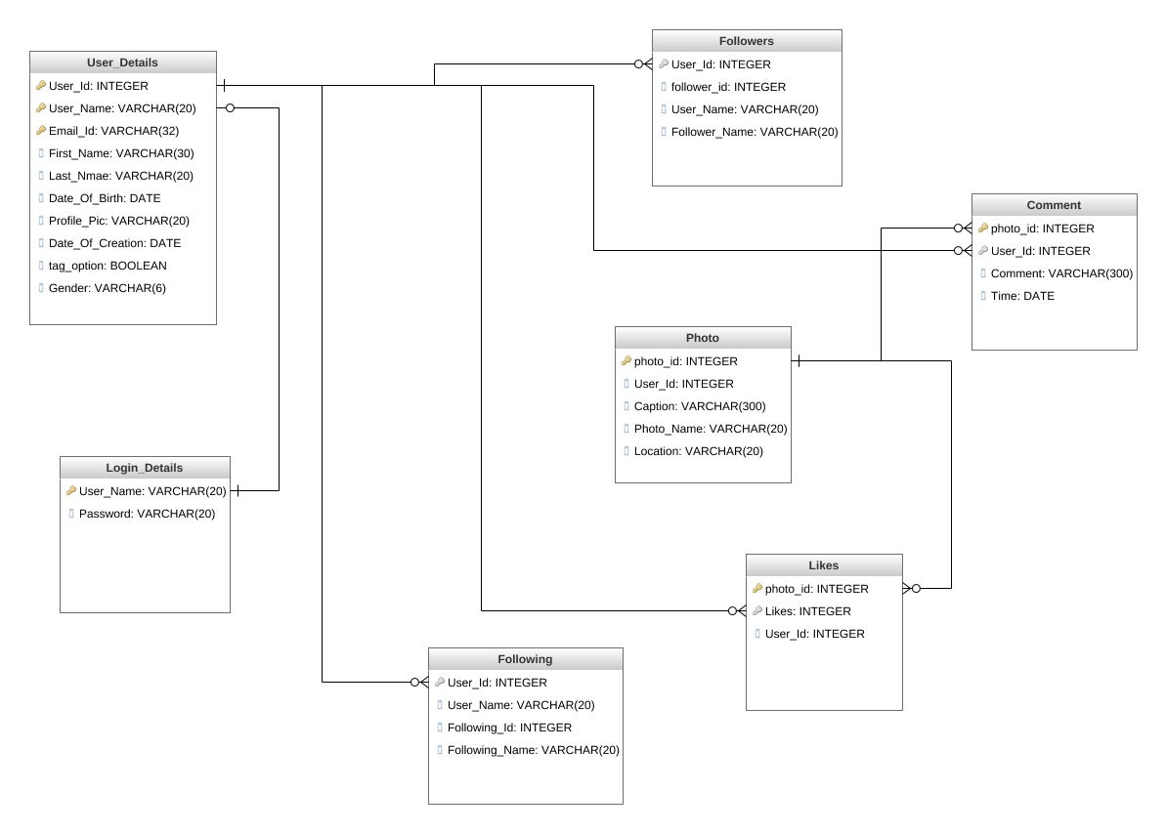

**ER-DIAGRAM:**

